

Session: 487

Hands-on with the IBM MQ Light API:
Cloud, Developer and Enterprise

Lab instructions

Lab User Name: demo
Lab Password: sample

Author:
Charlie Martin, IBM Messaging Development


IBM may not offer the products, services, or features discussed in this document in other countries. Consult your local IBM representative for information on the products and services currently available in your area. Any reference to an IBM product, program, or service is not intended to state or imply that only that IBM product, program, or service may be used. Any functionally equivalent product, program, or service that does not infringe any IBM intellectual property right may be used instead. However, it is the user's responsibility to evaluate and verify the operation of any non-IBM product, program, or service.
IBM may have patents or pending patent applications covering subject matter described in this document. The furnishing of this document does not grant you any license to these patents. You can send license inquiries, in writing, to:
IBM Director of Licensing
IBM Corporation
North Castle Drive, MD-NC119
Armonk, NY 10504-1785
United States of America
The following paragraph does not apply to the United Kingdom or any other country where such provisions are inconsistent with local law: INTERNATIONAL BUSINESS MACHINES CORPORATION PROVIDES THIS PUBLICATION "AS IS" WITHOUT WARRANTY OF ANY KIND, EITHER EXPRESS OR IMPLIED, INCLUDING, BUT NOT LIMITED TO, THE IMPLIED WARRANTIES OF NON-INFRINGEMENT, MERCHANTABILITY OR FITNESS FOR A PARTICULAR PURPOSE. Some states do not allow disclaimer of express or implied warranties in certain transactions, therefore, this statement may not apply to you.
This information could include technical inaccuracies or typographical errors. Changes are periodically made to the information herein; these changes will be incorporated in new editions of the publication. IBM may make improvements and/or changes in the product(s) and/or the program(s) described in this publication at any time without notice.
Any references in this information to non-IBM websites are provided for convenience only and do not in any manner serve as an endorsement of those websites. The materials at those websites are not part of the materials for this IBM product and use of those websites is at your own risk.
IBM may use or distribute any of the information you supply in any way it believes appropriate without incurring any obligation to you.
Information concerning non-IBM products was obtained from the suppliers of those products, their published announcements or other publicly available sources. IBM has not tested those products and cannot confirm the accuracy of performance, compatibility or any other claims related to non-IBM products. Questions on the capabilities of non-IBM products should be addressed to the suppliers of those products.
This information contains examples of data and reports used in daily business operations. To illustrate them as completely as possible, the examples include the names of individuals, companies, brands, and products. All of these names are fictitious and any similarity to the names and addresses used by an actual business enterprise is entirely coincidental.
TRADEMARKS
IBM, the IBM logo, and ibm.com are trademarks or registered trademarks of International Business Machines Corp., registered in many jurisdictions worldwide. Other product and service names might be trademarks of IBM or other companies. A current list of IBM trademarks is available on the web at “Copyright and trademark information” at www.ibm.com/legal/copytrade.shtml.
Adobe, the Adobe logo, PostScript, and the PostScript logo are either registered trademarks or trademarks of Adobe Systems Incorporated in the United States, and/or other countries.
Cell Broadband Engine is a trademark of Sony Computer Entertainment, Inc. in the United States, other countries, or both and is used under license therefrom.
Intel, Intel logo, Intel Inside, Intel Inside logo, Intel Centrino, Intel Centrino logo, Celeron, Intel Xeon, Intel SpeedStep, Itanium, and Pentium are trademarks or registered trademarks of Intel Corporation or its subsidiaries in the United States and other countries.
IT Infrastructure Library is a Registered Trade Mark of AXELOS Limited.
ITIL is a Registered Trade Mark of AXELOS Limited.
Java and all Java-based trademarks and logos are trademarks or registered trademarks of Oracle and/or its affiliates.
Linear Tape-Open, LTO, the LTO Logo, Ultrium, and the Ultrium logo are trademarks of HP, IBM Corp. and Quantum in the U.S. and other countries.
Linux is a registered trademark of Linus Torvalds in the United States, other countries, or both.
Microsoft, Windows, Windows NT, and the Windows logo are trademarks of Microsoft Corporation in the United States, other countries, or both.
UNIX is a registered trademark of The Open Group in the United States and other countries.
© Copyright International Business Machines Corporation 2015.
This document may not be reproduced in whole or in part without the prior written permission of IBM.
US Government Users Restricted Rights - Use, duplication or disclosure restricted by GSA ADP Schedule Contract with IBM Corp.

Resource guide
IBM Technical Client Training has enhanced its training capabilities, and extended reach into new cities and countries, by partnering with five highly qualified IBM Business Partners who provide high quality, authorized training for IBM Clients, IBM Business Partners, and IBM employees. IBM continues to provide authorized training curriculum and content, and also maintains overall ownership of the IBM Training ecosystem.
The delivery of public, private and customized training to IBM Clients and IBM Business Partners is now done by the IBM Global Training Providers (GTPs):
- Arrow
- Avnet
- Global Knowledge
- Ingram Micro
- LearnQuest
See ibm.com/training for information on the classes that the GTPs offer.
Completing this InterConnect lab is a great first step in building your IBM skills. IBM offers several resources to keep your skills on the cutting edge. Resources available to you range from product documentation to support websites and social media websites, including the following examples:
- IBM Training website
- Bookmark the IBM Training website for easy access to the full listing of IBM training curricula. The website also features training paths to help you select your next course and available certifications.
- For more information, see http://www.ibm.com/training
- IBM Certification
- Demonstrate your mastery of IBM products to your employer or clients through IBM Professional Certification. Certifications are available for developers, administrators, and business analysts.
- For more information, see http://www.ibm.com/certify

What you will learn
This lab will teach you how you can improve the responsiveness and scalability of your web applications, both on premise and in the cloud by using messaging with the MQ Light API.
It will explain how to off-load heavy workloads to separate worker threads while your web handlers deal quickly and efficiently with the requests from your online users.
As software developers we want our applications to be responsive and scalable to really engage users, but it's not always easy to write code that behaves like this. The MQ Light API, available in IBM MQ and the Message Hub Service in IBM Bluemix, is a great tool that helps applications off-load work to be dealt with asynchronously thus ensuring your applications responds quickly. Additionally, as workload increases, applications that use MQ Light become very easy to scale up.
In this Lab you will learn how to use the MQ Light API, develop an application which runs locally using the MQ Light Developer Tools before deploying it to the Cloud using IBM Bluemix and the Message Hub Service. You will also learn how to use the iMQ Light user interface to understand and debug the messages that your application has sent and received.

What the lab covers
This lab has the following parts:
- Running the sample applications.
- Running and improving an application by separating the web-facing component from the data-processing component.
- Scaling up to demand with more workers and different languages
- Deploying your finished application to IBM Bluemix to run it in the cloud using the Message Hub Service.

Setup – Extract the source for the labs
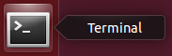
- Open a terminal window and change directory to /home/demo/mql (‘l’ for light) by running: cd /home/demo/mql
- Extract the source files from git by typing “./extract-lab.sh” and hitting enter.
This should extract the projects that we will be using to run the lab into the lab directory.
Note: If step 2 failed - for example because of network problems, there is a backup copy of the lab files in /home/demo/mql/backup-lab-files - ie
from /home/demo/mql run
cp -r backup-lab-files/ lab
To copy the lab files to the lab directory and then continue as normal from step 3.
- If you wish to run the Bluemix parts of the lab you will need to get a Bluemix ID and have sufficient memory available when MQ Light apps are deployed to your Bluemix environment (eg. stop ‘old’ applications running in Bluemix). We suggest that (if you haven’t done so) you sign up for an account at www.bluemix.net so you can complete the Bluemix sections.
You should now be ready to run the lab!

Part 1 – Running the sample applications
First, we'll start MQ Light and run some sample applications to show the basics of how it works.

Start MQ Light
Open a terminal, run
cd /home/demo/mql/mqlight
and run:
./mqlight-start
This will start up the MQ Light runtime so other applications can connect to it and use it to send messages. If this is your first time running MQ Light, you will need to press 1 and hit enter to accept a licence, then type 'N' to the security questions as we won't need them for t$his lab.

Check the MQ Light UI
Once MQ Light has started up, a browser window will open which will look like this: 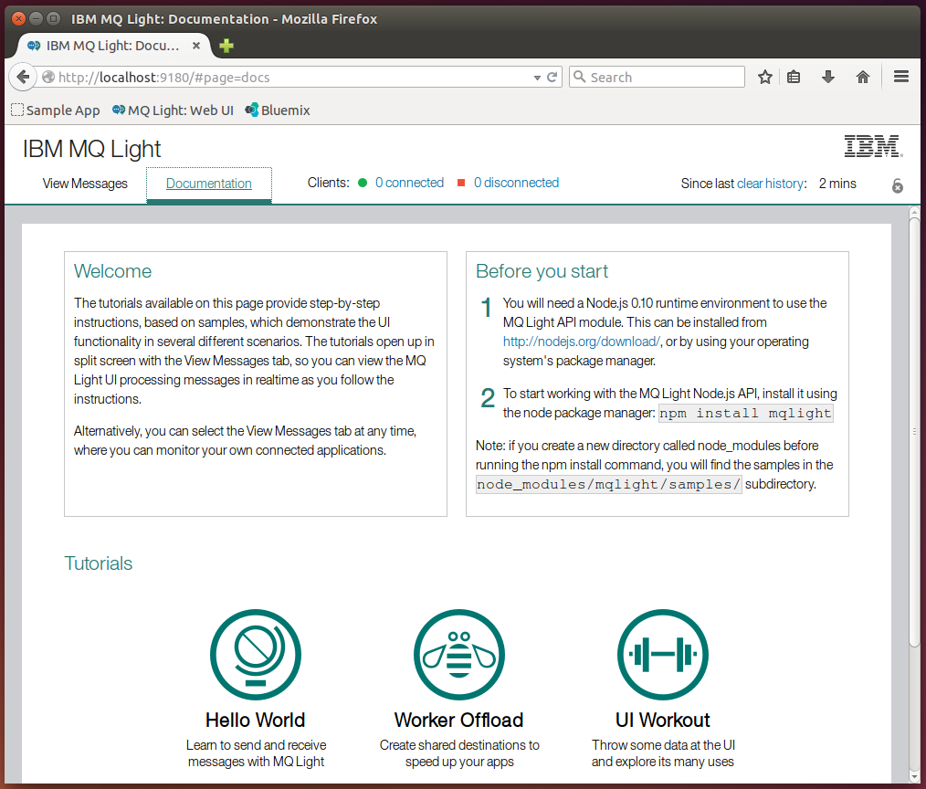
The Documentation tab explains how to run some sample apps that we will be going through shortly, as well as how to install some MQ Light client libraries. Click the View Messages tab in the top left and you will be shown the main view of the UI: 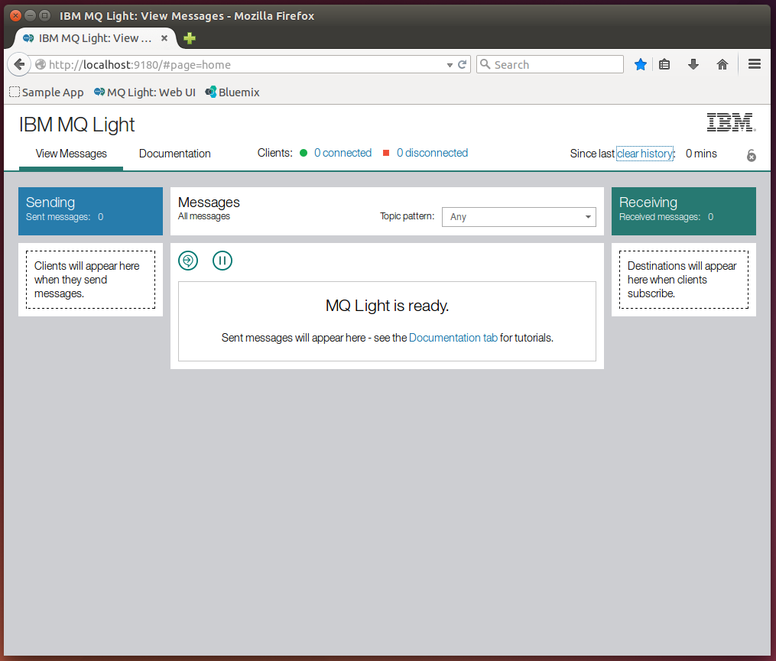
This screen shows the current state of the MQ Light runtime, including connected clients and the status of messages. We'll be referring back to and explaining this screen throughout the lab.

Start a Node.js receiver application
Back in an Ubuntu terminal (click the icon to launch), run:
cd /home/demo/mql/samples/node
Here, we have a node_modules directory as we have already installed the node modules needed to run these samples, so you can now run:
node recv.js
Which will start a simple node application that will subscribe to the topic pattern public: 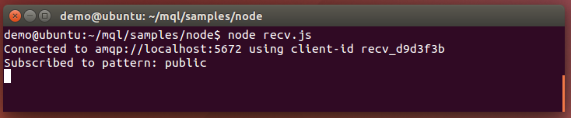
When a message is sent to the topic ‘public’, it will be displayed here. Switch back to the MQ Light UI, we can see one connected client listed as a receiving client (because it has subscribed to a destination): 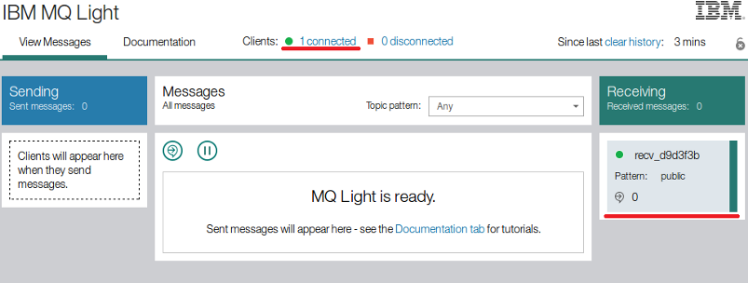

Send a message to the receiver application
Open a new terminal window by right clicking the terminal icon → New Terminal and change directory to the /home/demo/mql/samples/node directory (leave the recv app running in the original window) and run the command:
node send.js
This application will send a message containing the text “Hello World!” to the topic 'public', then exit: 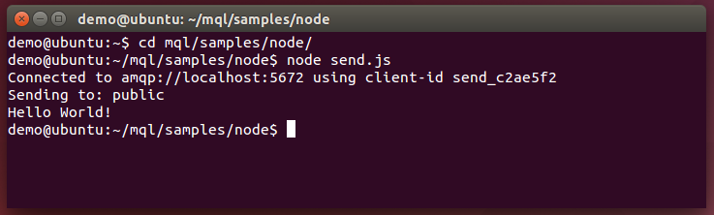
Checking the UI, we can see that one sending client is listed as disconnected (because it disconnected right after sending the message):
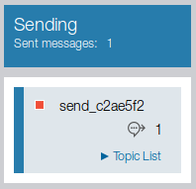
In the centre of the window, we can see the message that has been sent: 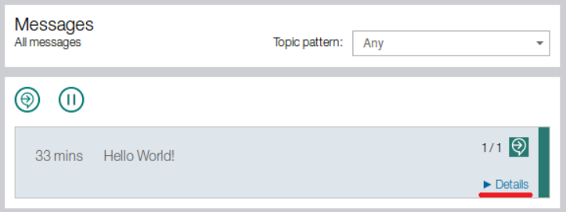
Clicking the details button (highlighted) in the bottom right gives us more details on the sent message:
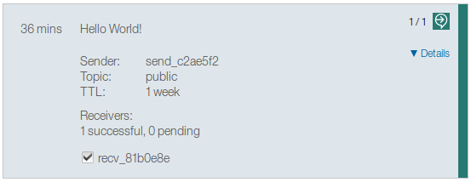
Here, we can see the payload of the message was 'Hello World!', the sender's id, the topic it was sent to and the time to live (TTL) of the message. We can also see the clients it was successfully delivered to (marked with ticks). If you move the mouse to hover over the arrow icon in the top right, it will tell you that the message has been successfully received.
Now go back to the terminal window where you ran the recv application and we can see that it has received the message: 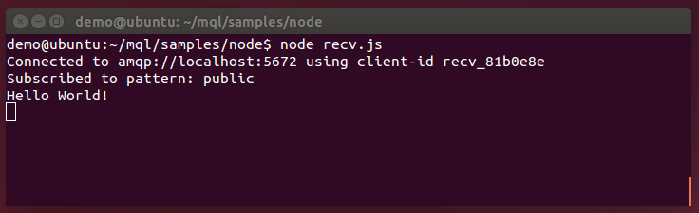

Send a message from a Ruby client to a Node.js client.
Let's send a message from Ruby now. Keeping the original recv app running, open another new terminal window and change directory to /home/demo/mql/samples/ruby
From here, run:
ruby send.rb
As with the Node sender, this will send a message to the topic 'public' and then exit: 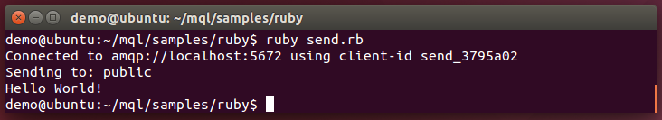
Checking the UI, you should see things update much as before (even if things appear a little slow and unresponsive at this point of the labs). Looking at the Node.js recv app, we can see this message came in as well. Just like that, we have a Node.js and Ruby application talking to each other.

Identify a message sent to the wrong topic
So far all the messages we've been sending have ended up at their intended destinations, but what if we get something wrong? Run the Ruby send application again, but this time with another option:
ruby send.rb -t wrongtopic
The -t option specifies the topic the message will be sent to (if left unset, it defaults to public): 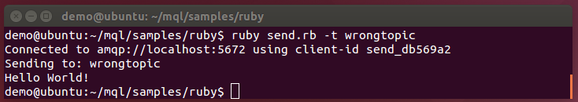
The recv app we have running is listening on ‘public’, so this message won't get through to it. This is the kind of problem you might encounter when developing messaging apps (as we'll be doing in the next section), so the MQ Light UI is designed to help you track down these common problems.
Imagine you sent that message, expecting it to be delivered to a receiver, but you mistyped the topic string and it doesn't arrive. Checking the MQ Light UI will give you info on what went wrong:
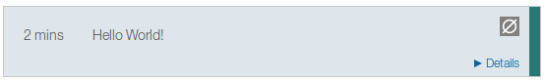
At a glance, we can see a different icon in the top right showing that something is wrong (we'll discuss what shortly) but also that message has been sent and picked up by MQ Light, ruling out network issues between the sender and MQ Light. Clicking the details button gives us:
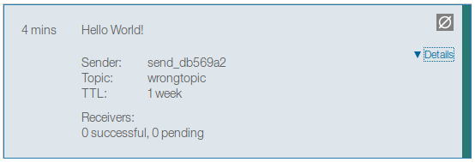
Now, we can see at the bottom that there are no receivers listed (successful or pending). If we had pending receivers, this would indicate an issue communicating with the receiver, helping us narrow down the issue further. If we mouse over the icon in the top right, we can get the information we need to solve the issue:
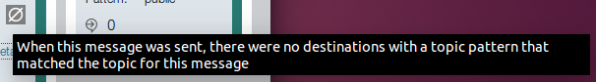
This tells us that message was sent to a topic pattern that no-one was listening to. We can then check the topic of the message (wrongtopic) and compare it to the topic of the receiver (public) and clearly see the issue – we sent the message to the wrong topic – an easy mistake that MQ Light helps developers to track down and fix.
Now, let's look at an app that can be improved using MQ Light.
(You should now stop the original recv.js app by switching to the terminal window in which it is running and pressing ctrl-c)

Part 2 – Running and improving an application by separating the web-facing component from the data-processing component.

Run the application that needs improvement
In a terminal window, change directory to /home/demo/mql/lab/node/no_worker.
Here we can see the application files, but before we can run it, we'll need to run:
npm install
This asks the Node.js package manager called “npm” to read the application's dependencies from package.json and install all the necessary modules: 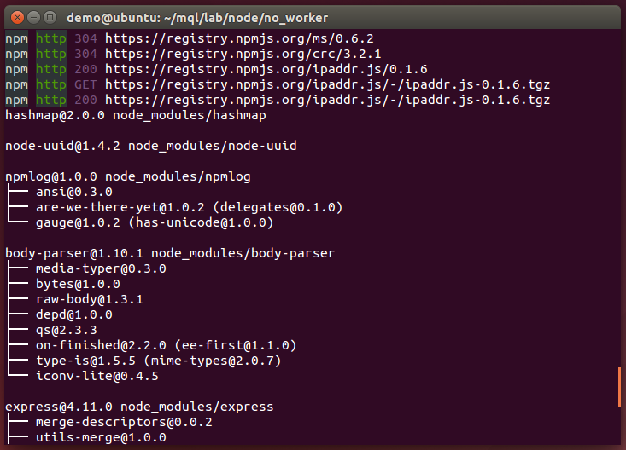
We can now run the app using:
node app.js
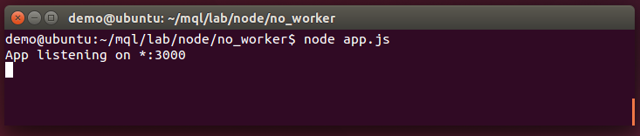
The app is listening on localhost:3000, switch to your browser and open that page in a new tab (keep the MQ Light UI open, as we'll be using it later). You can also click the ‘Sample App’ button in the bookmark toolbar to jump straight to localhost:3000:
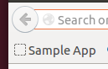
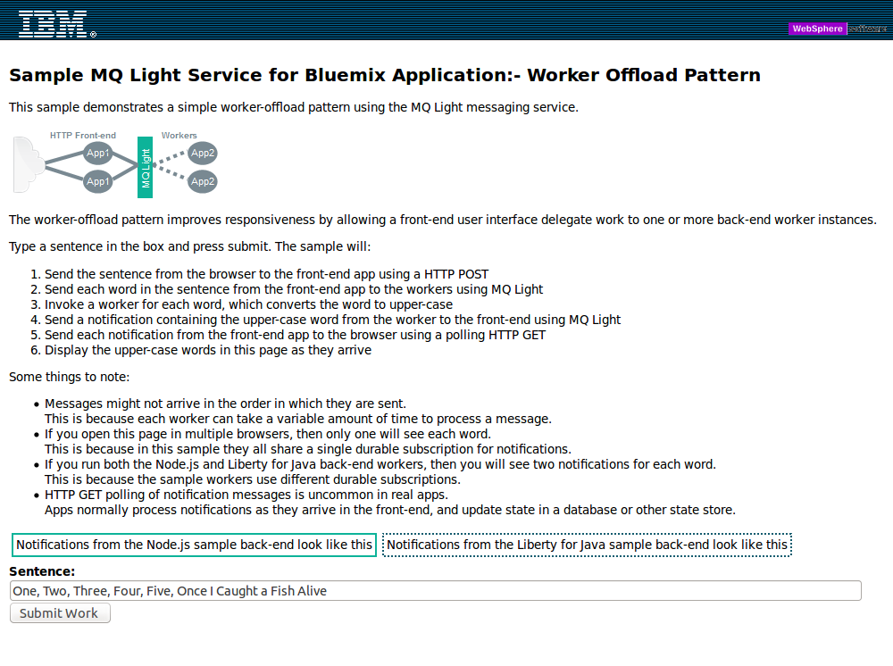
You can ignore the text for now (it is written assuming you are already using MQ Light). When you click the 'Submit Work' button, the words in the text box are sent to the Node app by way of a HTTP POST, where the are 'processed' and sent back to the webpage using HTTP where they are displayed. The processing involves capitalizing the words and sleeping for a short time to simulate the more intensive processing that might need to take place in a real application.
The problem is that although the capitalised words are displayed, there is a significant lag before they appear:
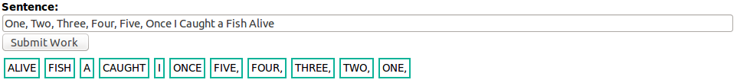
This wait is due to the fact the Node.js is single threaded by design and all time consuming processing (or waiting, in this case) will hold up the rest of the app. This is bad, as you always want your apps to be as responsive as possible – luckily, it's exactly the kind of problem MQ Light can help with.
If we move the time consuming processing to a separate application, it can take its time processing while the front-end app is free to be as responsive as possible. Normally, it is not easy to communicate between Node.js threads, but by running the samples, we've seen how MQ Light can send messages between different Node.js applications – we can use this move the heavy work to separate 'worker' apps which can run either on the same machine or be distributed out to different worker machines in a cloud-like deployment.

Update the front-end app to send its work away using MQ Light, instead of processing it locally
In the terminal window where you started “node app.js” hit ctrl-c to quit the application and then open up the app.js file in the editor “gedit” by typing:
gedit app.js
This should open a window like this:
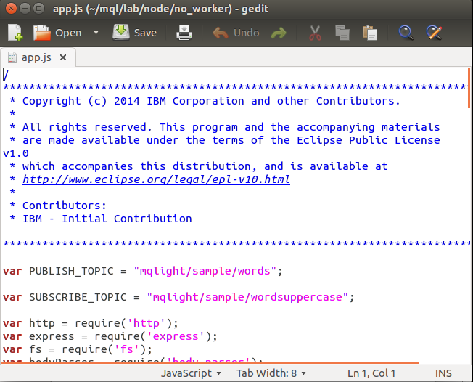
NOTE: Whenever we ask you to write in code, we have included the code you need insert in a file called snippets.js in the same directory as app.js. Open it now (from the same ‘gedit’ session) and you can see that we have labelled each individual snippet (in snippets.js) so you can find and copy them easily. There are corresponding labels showing where to paste this code in app.js. Only paste the snippets as instructed below (others in snippets.js are used in later labs)
Make sure you have the following 2 lines near the top of app.js file so they can be used later:
// SNIPPET 1
var PUBLISH_TOPIC = "mqlight/sample/words";
var SUBSCRIBE_TOPIC = "mqlight/sample/wordsuppercase";
The SUBSCRIBE_TOPIC is the topic we'll be listening for messages from the worker on and the PUBLISH_TOPIC is the topic where we'll send our work to be processed.
Now, paste the following code near the top of the file, after all the require statements:
// SNIPPET 2
var mqlight = require('mqlight');
var opts = {};
opts.service = 'amqp://localhost:5672';
This will use the MQ Light module and configure the start-up options to connect to the default MQ Light address.
Next, we'll add code to create an MQ Light client:
// SNIPPET 3
var mqlightClient = mqlight.createClient(opts, function(err) {
if (err) {
console.error('Error ' + err);
} else {
console.log('Connected with id ' + mqlightClient.id);
}
});
Finally, we can add the code to actually send the worker. Look for the line:
processMessage(msgData);
in stanza app.post('/rest/words' … which is where we process. All we need to do it replace that line with:
// SNIPPET 4
mqlightClient.send(PUBLISH_TOPIC, msgData);
Now save the file and quit the editor.
Before we can run the changed app.js file we need to ask the node package manager “npm” to install the mqlight package. You can do this by changing to the /home/demo/mql/lab/node/no_worker directory and running:
npm install mqlight
This will install the MQ Light node module you'll need to connect your apps to MQ Light. You can now run the updated front-end with:
node app.js
You should see it start as before, but now it will also report that is connected to MQ Light and print its client id:
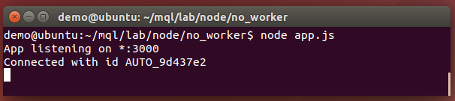
NOTE that if you do not see the app connect as shown above, you should check to make sure you have saved the version of app.js that you just edited.
If point your browser at localhost:3000 again, you should see the same interface as before, but now if you press the 'Submit Work' button nothing will be output on the screen. If we check the MQ Light UI, we can confirm that messages were sent, but no worker received them.
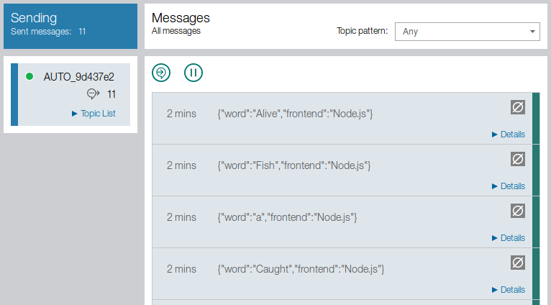
This is expected because we don't have a worker to do the processing and send it back to the front-end. Let's make that worker now.
Before we do that, “clear the history” in the MQ Light window by clicking on the words “clear history”:
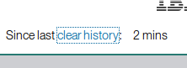

Move the time intensive work to a separate worker app.
In a terminal window open app.js and look for the processMessage function (near the bottom of the file):
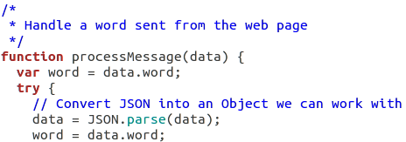
Here, we are taking the word sent from the web page and performing the (time intensive) processing on it. This is what is slowing the app down, so let's move it to a separate app. Create a file using ‘gedit’ (click ‘+’ symbol for new file) in the same directory as app.js called worker.js and copy and paste the processMessage function (and the sleep function below it) from app.js into your newly created worker.js so that your worker.js file (when saved) looks like this:
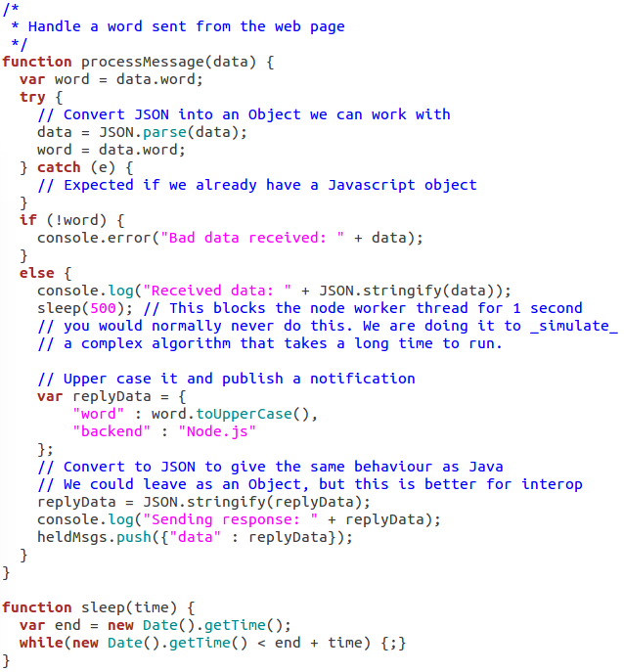

Set up the worker to receive work from the front end.
In isolation, this code won't do anything, so we'll need to add some code (from snippet.js) that will allow it to connect to MQ Light. Copy the following code to the top of the file, much as we did for the front-end:
// SNIPPET 5
var mqlight = require('mqlight');
var opts = {};
opts.service = 'amqp://localhost:5672';
Below this, we'll define some variables based on the topics the worker will be using:
// SNIPPET 6
var SUBSCRIBE_TOPIC = "mqlight/sample/words";
var PUBLISH_TOPIC = "mqlight/sample/wordsuppercase";
The SUBSCRIBE_TOPIC is the topic we'll be listening for messages from the front-end on and the PUBLISH_TOPIC is the topic we'll send back our processed message on.
Now add the following code below snippet 6, which will create an MQ Light client, have it subscribe to the correct topic and then send the messages it receives to the processMessage function we copied over earlier:
// SNIPPET 7
var mqlightClient = mqlight.createClient(opts, function(err) {
if (err) {
console.err('Error: ' + err);
} else {
console.log('Connected');
}
mqlightClient.on('message', processMessage);
mqlightClient.subscribe(SUBSCRIBE_TOPIC, function(err) {
if (err) console.err("Failed to subscribe: " + err);
else { console.log("Subscribed"); }
});
});
In the 'message' event (ie. When a message arrives), the message payload is passed straight to the processMessage function, where it will be processed just as in the original. Now we just need to make it send the processed word back to the front-end.

Set up the worker to send work back to the front end.
Looking at the processMessage function in worker.js, all we need to change is the final line from:
heldMsgs.push({"data" : replyData});
to:
// SNIPPET 8
mqlightClient.send(PUBLISH_TOPIC, replyData);
In the original app, we pushed the data to an array from which it was popped and sent to the web-page, but now, we just need to send it to the front-end using MQ Light.
We can run the worker app now. Save worker.js and app.js and run worker.js with:
node worker.js
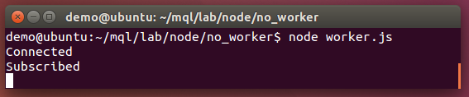
Leave this running and (ensuring your updated front-end app.js is also running) point your browser back to localhost:3000 and remove all but one word from the text box ‘sentence’ (this will allow us to better keep track of what is being sent through MQ Light).
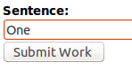
Click the Submit Work button. Again, nothing will be output on the screen. Check the MQ Light and expand the message details.
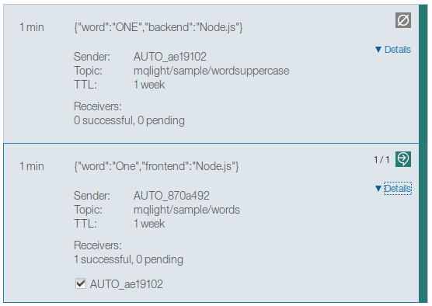
The bottom (earliest) message is from the front-end to the worker. We can now see that it has been successfully delivered to the worker as expected. The newer (top) message is the processed (capitalized) word from the worker. We can see that it has been sent, but not received by any clients. Let's fix that.

Update the front-end to receive the processed message from the worker
Looking back at app.js, we need to add a function that will get the received message where it needs to be. Stop the process in the terminal currently running app.js and open it with ‘gedit’.
Add the function “ handleProcessedMessage” to the file, just under the line that starts “opts.service” so that the file looks like this:
opts.service = 'amqp://localhost:5672';
// SNIPPET 9
function handleProcessedMessage(msg) {
heldMsgs.push({"data" : msg});
}
Then, looking back at where we create the MQ Light client, we'll need to add a bit of code to that block that will subscribe to the correct topic and send any received messages to the handleProcessedMessage function. Copy in the code such your file looks like this (effectively replacing snippet 3 with snippet 10):
// SNIPPET 10
var mqlightClient = mqlight.createClient(opts, function(err) {
if (err) {
console.error('Error ' + err);
} else {
console.log('Connected with id ' + mqlightClient.id);
}
mqlightClient.on('message', handleProcessedMessage);
mqlightClient.subscribe(SUBSCRIBE_TOPIC , function(err) {
if (err) console.err("Failed to subscribe: " + err);
else { console.log("Subscribed"); }
});
});
Finally, save and re-run your app.js and press the Submit Work button. The words should now appear on screen.
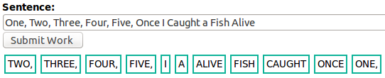
If you check the MQ Light UI, you can see all messages listed as received. Importantly, we no longer have a huge lag before messages start appearing because we aren't holding up the main thread with all the processing. The messages still take time to come in though (the processing still needs to be done, of course). We can address this issue by scaling up the number of workers, which will be the subject of our next section.

Part 3 – Scaling up to demand with more workers and different languages
Currently, we have a Node.js front-end and a Node.js worker. The CPU intensive work has been moved to worker app, making the front-end more responsive, but the work still takes roughly the same length of time. We can improve on this by scaling up the number of workers we are using. By having multiple workers processing each word in parallel, they can complete more work in the same amount of time.

Switch to the pre-made front-end and worker.
If you followed the previous section, will switch to a new, ready-made version of the front-end and worker apps. We’ve made a few small changes to the apps that we'll talk about in the next section.
First, stop any of the Node.js apps you currently have running by switching to the terminal window in which they are running and pressing ctrl+c. You can then close those windows. Also clear the history in the MQ Light console:
Open up 2 new terminal windows. In one, change directory to /home/demo/mql/lab/node/ frontend/ and in the other change directory to /home/demo/mql/lab/node/backend/. These are the front-end app and back-end (worker) app, respectively and we'll refer to them as such from now on.

Examine the differences in the new worker.
To start with, in the frontend directory, run:
npm install

followed by:
node app.js
This will start the front-end app. You can leave this running for the remainder of this section.
In your version the worker thread, we subscribed to a private destination with a topic pattern 'mqlight/sample/words'. This means that it receives a copy of every messages published to that topic. If we simply started another instance of that worker application, both instances would receive a copy of every word. This would mean that each word would get processed twice which we don't want to do.
To change this behaviour we need both of the worker applications to share the messages between them. The way we can do this using the MQ Light API is to make the worker threads join a “shared destination”. A shared destination allows a group of applications to share the processing of messages arriving that the destination. Each message arriving at the destination is only given to one of them.
In the original worker app, we subscribed using this line of code:
mqlightClient.subscribe(SUBSCRIBE_TOPIC, function(err) {
The first argument is the topic we will subscribe to and the last argument is the function that will be run when the subscribe operation completes. We'll need to change this if we want to use a shared destination. If we look at the subscribe call in the new backend/app.js we see:
mqlightClient.subscribe(SUBSCRIBE_TOPIC,
SHARE_ID,
{credit : 5, autoConfirm : true, qos : 0},
function(err) {
The first and last arguments are the same. The third argument lists some options. Many of these are default values and relate to how many messages we will take on before waiting to process what we have (credit), whether or not we automatically confirm that we have received a message (autoConfirm) and the quality of service (qos). Importantly, the second argument specifies a name for the shared destination we will be subscribing to. In this case, the SUBSCRIBE_TOPIC is node-back-end.
In the backend directory, run:
npm install
followed by:
node app.js
Now, switch to the MQ Light UI and look in the Receiving column on the right of the screen:
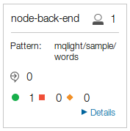
You'll notice this looks different to the apps you've run previously, because this is a shared destination. The head icon in the top right shows number of clients connected to this shared destination. The shared destination name (node-back-end) is listed at the top, as is the actual topic pattern it is subscribed to.
If we open the web-app itself (still on localhost:3000), we should see the same app and if we press the Submit Work button, we should see the same speed as when we were using the our worker app. This is because we still have only one worker app – shared destinations shine when we have more than one worker app. Open another terminal window, change directory to the backend directory, and again run:
node app.js
Check the MQ Light UI again and we can see the node-back-end shared destination has updated to reflect that another client has connected to it. Click the Details button to get more details:
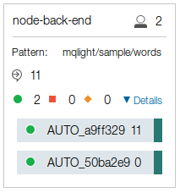
Here can see the ids of both clients connected to this shared destination and how many messages they have each processed (the 11 is the messages we just sent by pressing the Submit Work button). Heading back to the web app, click the Submit Work button again and we should see better performance. Importantly, if we look at the MQ Light UI again, we can see that the messages have been distributed between the clients, while at the same time, no work has been duplicated.
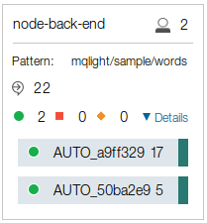
If you choose to, you can now start even more instances of the worker app and observe how they improve performance. With MQ Light, we have improved an app so its performance is now only bound by the physical machines it is running on, rather than the single threaded nature of Node.js.

Run a Ruby worker alongside the Node.js worker.
We can also run a Ruby worker app alongside the Node.js ones we are already running. To do so, open another terminal window and change directory to /home/demo/mql/lab/ruby/backend. Here we have a Ruby worker application that does the same as the Node.js workers. Run this app with:
ruby sinatra_backend.rb
Click the Submit Work button in the web app and observe the results.
As the Ruby and Node.js workers are using a shared destination, it means the work is distributed between them, the border color of each word indicating which backend processed each message:
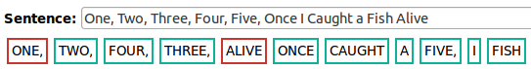

If we wanted each word to be processed by both workers, we just need to make the Ruby worker subscribe to a different shared destination from the Node.js worker. To do that, simply open /home/demo/mql/lab/ruby/backend/sinatra_backend.rb in a text editor and change line 18 from:
SHARE_ID = 'fishalive-workers'
to
SHARE_ID = 'fishalive-workers-ruby'
Then restart the app (ctrl+c, then run it again) and the app now will connect to a different shared destination then the Node.js worker.
Finally, click the Submit Work in the web app and we can see all the work is processed by both the Ruby and Node.js workers:
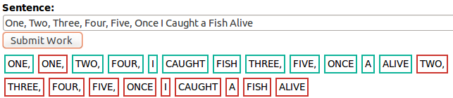
So far in this lab, we have taken single Node.js app that was unresponsive, improved it using MQ Light to make it much more scalable and responsive. We have even distributed work between Node.js and Ruby worker apps, empowering programmers with different skillsets to work on the same problem using the worker-offload pattern. The final step is to push it to production.

Part 4 – Deploying your finished application to IBM Bluemix to run it in the cloud
Now we have an application running locally, we are ready to push it to Bluemix. There, it will run in the cloud, exactly as it did locally, with services such as Message Hub, runtimes such as Node.js and Ruby being managed for you.
To do this part of the lab you will need to sign up to IBM Bluemix which you can do at https://bluemix.net/. Once you have signed up and logged in to Bluemix you will be presented with the Bluemix dashboard:
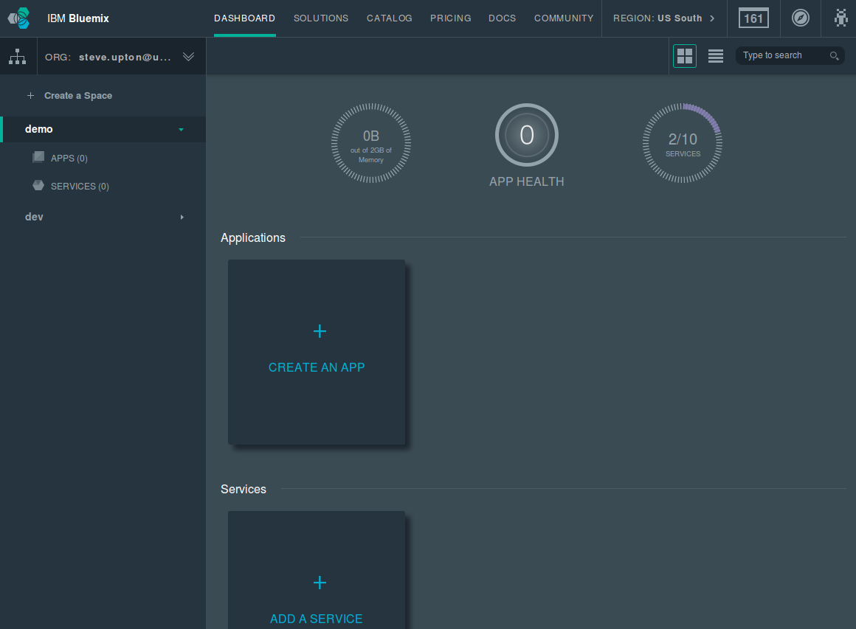
You will start with zero apps and zero services (albeit your Bluemix dashboard may already have other apps or services installed in your ‘Space’) - so let’s change that by getting a Message Hub service instance deployed.

Create a Message Hub service instance
We're going to create a Message Hub service called MQLight-sampleservice (no space) that our apps can connect to when we push them to Bluemix. Scroll down to the Services section of the Bluemix dashboard and click Add a Service or alternatively, click on ‘Use Services or APIs’:
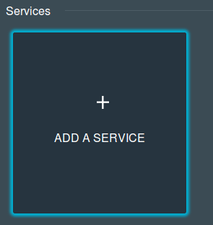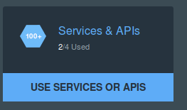
You'll be presented with a catalog of services available to you. Scroll down to the Web and Application section and click Message Hub:

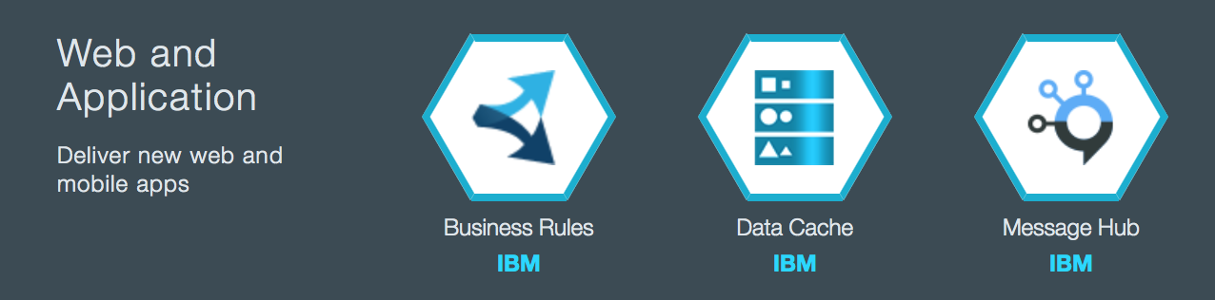
On the next screen, you can configure the service before you create it. On the right hand side, you can see the Space (leave it as your default space), the App to bind it to (leave it unbound, as you don't have any apps yet) and the Service Name (enter MQLight-sampleservice) and click CREATE:
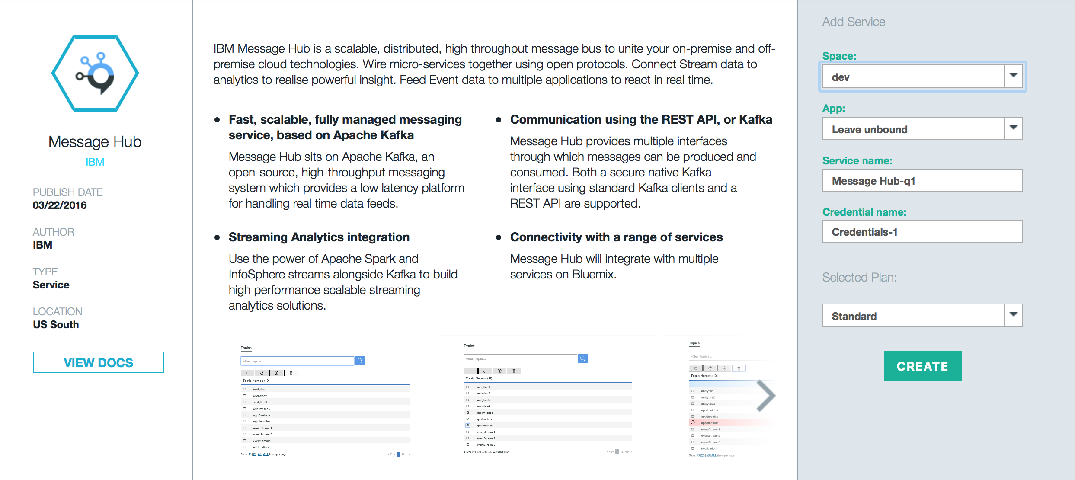
A Message Hub instance will then be set up for you – it can take a little while. After a short wait, you will be shown the UI:
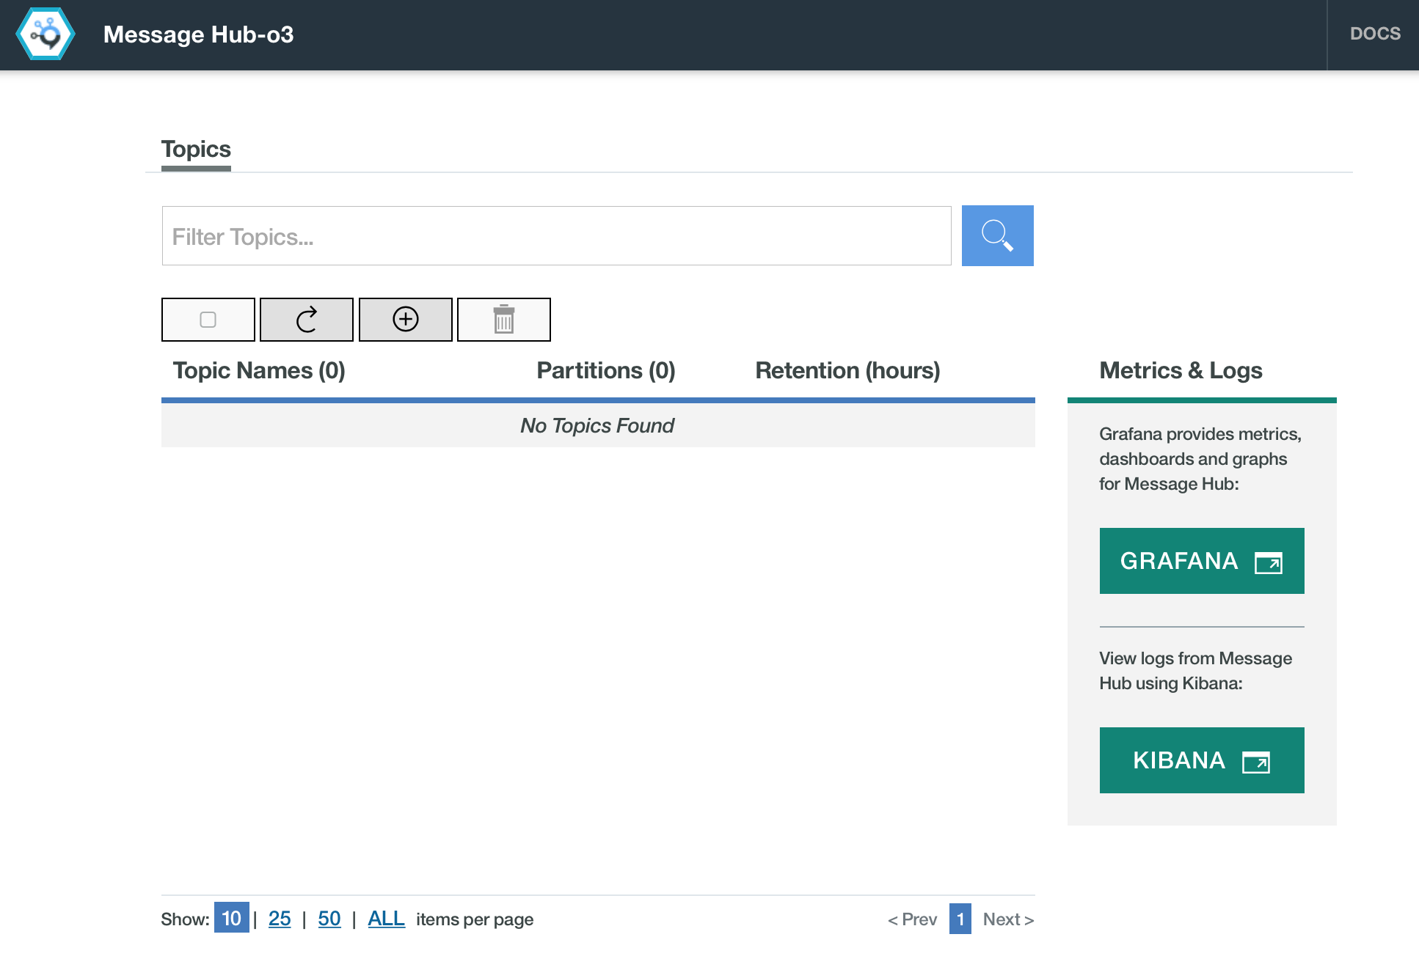
Create a topic called MQLight by clicking on the [+] button, and accept the defaults for the number of partitions and the retention time. Once you’ve created the topic, the list of topics looks like this:
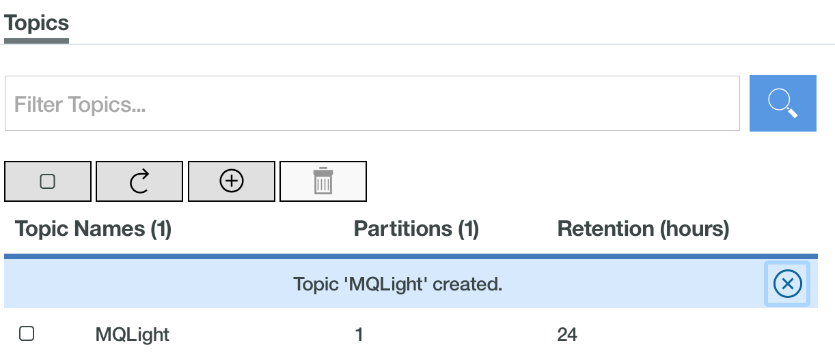
Click Back to Dashboard to return to the Dashboard for now. Now, let's look at getting your apps into Bluemix.

Configure the cf tool
We will be using the cf tool to push our applications into Bluemix, so let's configure that first. We've installed the tool for you, but you'll need to enter your Bluemix login details before you can use it. Assuming your Bluemix region is ‘US South’, from a terminal window, run:
cf api https://api.ng.bluemix.net
If you are using Bluemix in London, the correct URL is: https://api.eu-gb.bluemix.net
This will tell your cf tool where you will be deploying your apps (Bluemix):
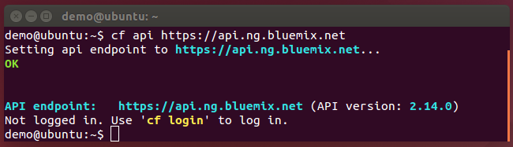
Next, you'll need to enter your login details. If you are presented with another set of credentials (from this VM image) as ‘being logged in’ – simply ignore and re-login to your space by running:
cf login
and enter your Bluemix login details (“Email ID” may actually your Bluemix Login ID, short-form in some cases) including entering your password, when you are prompted:
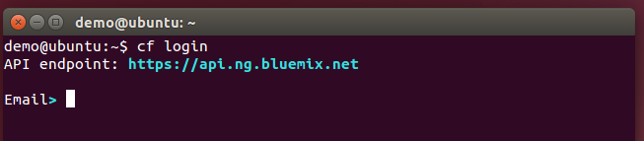
This step may take a few seconds to complete. If you are prompted, select an Org and a Space (eg. ‘Dev’). You are now ready to push your apps into Bluemix!

Push your apps into Bluemix
This is the simple part. Open a new terminal window and change directory to /home/demo/mql/lab/node.
Run:
cf push
The cf tool will then read metadata from manifest.yml file in that directory to configure and run the app for you. This will take a little time, approx. 5 minutes, but after the command has finished running, check your Bluemix Dashboard to see 2 newly created apps:
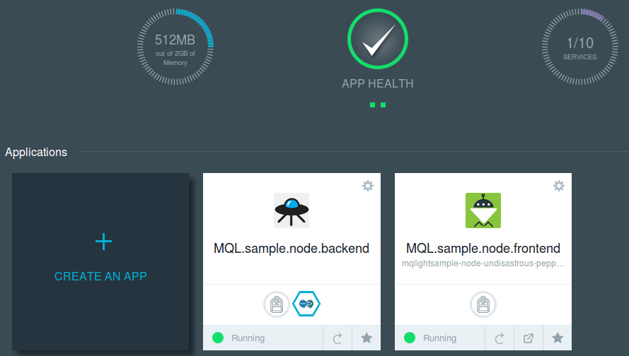
We have 1 instance of the Node.js front-end and 2 Node.js worker instances, both connected to the same Message Hub service – all with one command! If you open the /home/demo/mql/lab/node/manifest.yml file in a text editor, you can see how we're configuring things:
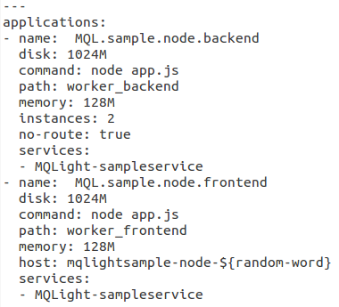
We can see 2 applications defined, one for the front-end and the other for the back-end. The options here are read by the cf push command and used to configure the apps:
- name is the name of your application in Bluemix.
- disk is how much disk space your application has.
- command is the command that is run to start your app once it is setup in Bluemix. In this case, it is the same command you used to start them locally.
- path is the path to the app on your local machine.
- memory is how much RAM you assign the app.
- instances indicates how many instances of the app Bluemix creates – this is only relevant to the back end worker.
- no-route indicates that the back end does not need a route (URL) created for it.
- host indicates the route (URL) to create for the front end (i.e. where the web app is available). Note that ${random-word} generates a random word that should lower the chances of trying the create an already taken route.
- services lists the services that you want to bind the app to upon creation. In this case it is the Message Hub service you created earlier.
This allows us to push the apps with a single command. In the Bluemix dashboard, scroll down and then click the Open URL button on the front-end app:
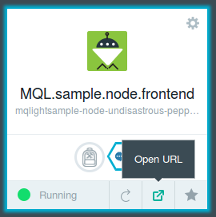
This will open the same web-app you were using locally. Click the Submit Work button to see it work in Bluemix.

Scale your apps in Bluemix
Right now we have 2 instances of the worker app running in Bluemix. But if we want more, scaling them in the cloud is even easier than locally. Returning to the dashboard, click the MQL.sample.node.backend app to be brought to its configuration page:
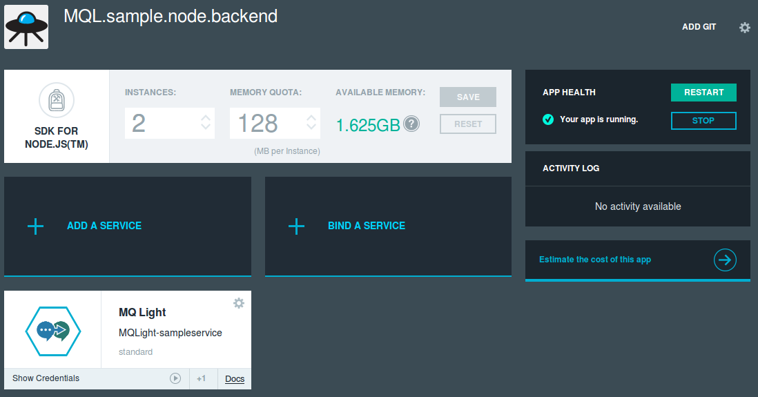
To start another instance of the worker app, perhaps to cater to demand, or increase performance, simply click the up arrow in the Instances box to increase the number of instances from 2 to 3:
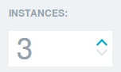
Then click save, to the right:
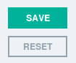
A new instance will be started, with no further need for action. Scaling is as simple as a single button press!

Push Java, Ruby and Python apps to Bluemix
If you choose to, you can also push equivalent Java and Ruby apps to Bluemix to run alongside the Node.js apps. Depending on your available resources in Bluemix, you may need to stop some running sample Apps (eg. if you’ve used Bluemix before) ie to make resources available, so your Ruby apps to run after deployment. For Ruby, open a terminal change directory to /home/demo/mql/lab/ruby where you can run:
cf push
As before, configuration details are read from the manifest.yml file and used set up the apps. For the Java apps, run cf push in /home/demo/mql/lab/java. When the apps are done deploying, head back to the original Node.js web app you had running in Bluemix. Click the Submit Work button to see that all the workers are processing the messages sent from the Node.js front-end app:
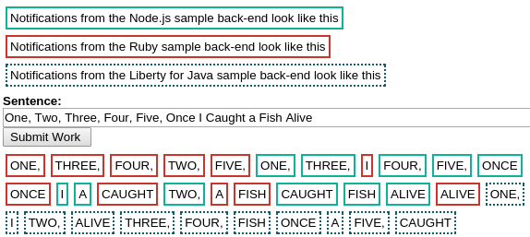

Congratulations! You've reached the end of the lab!
We've shown you how to use MQ Light to rapidly develop and debug your applications and you've learnt how MQ Light can make your applications more responsive.
You've also seen how the MQ Light API allows you to create multiple workers by joining them into a shared destination, allowing you to build a scalable app that can respond to change in demand.
Finally you've seen how you can deploy your applications to Bluemix, leaving you to worry about coding your applications while Bluemix manages the infrastructure and scales your application quickly and easily.

